***Vehicle Rental System***

**Date**: 14/02/2019

**Guide**: Ankitha Philip

**UML DIAGRAM**

1. **STRUCTURAL DIAGRAMS**

**A.** **Class diagram**

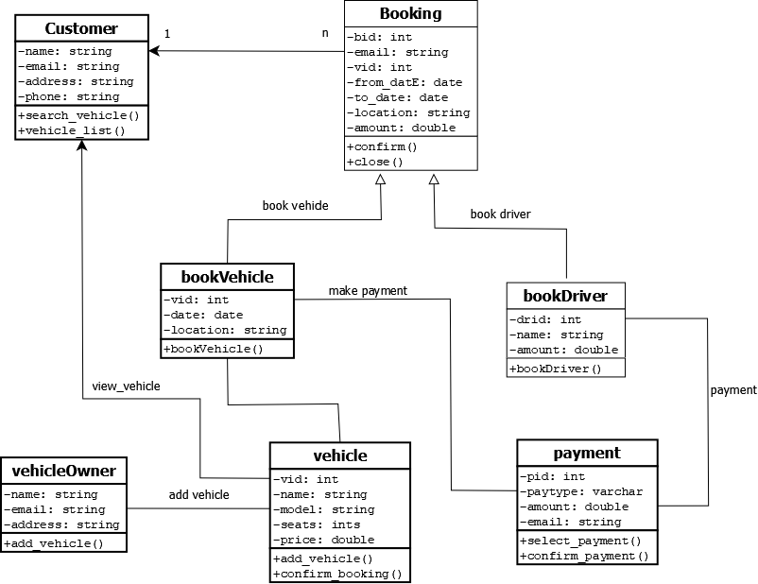

**B.** **Object diagram**

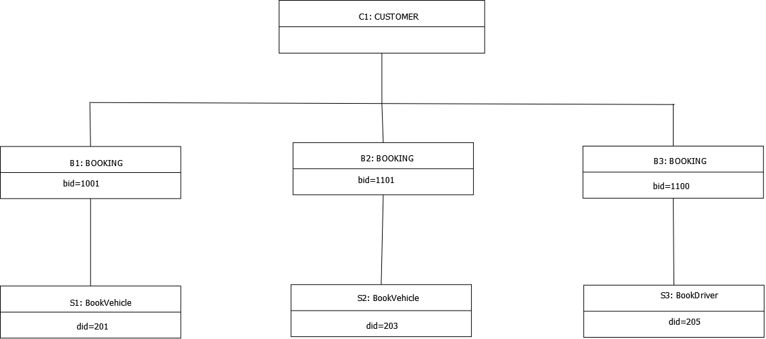

**D.** **Deployment diagram**

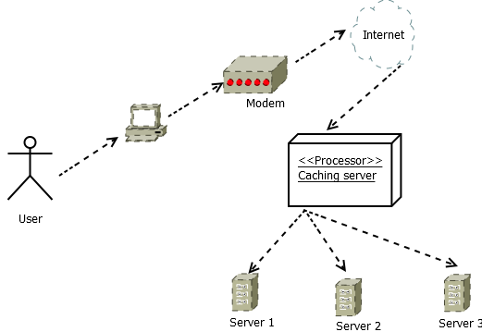

2.**BEHAVIORAL DIAGRAMS**

**A.** **Use case diagram**

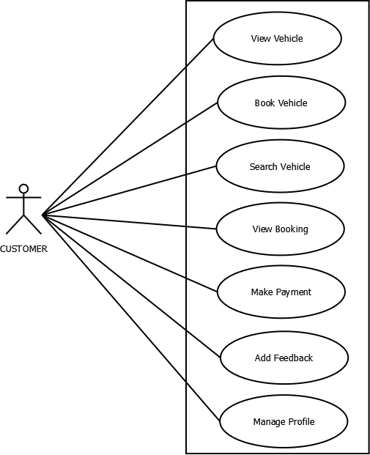

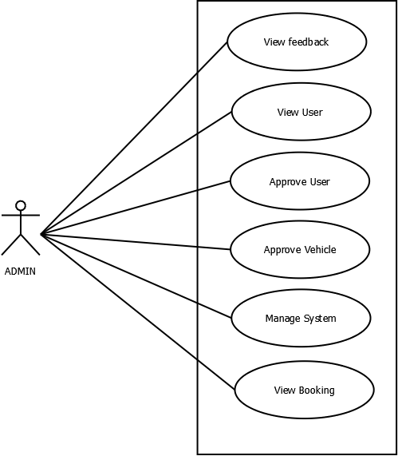

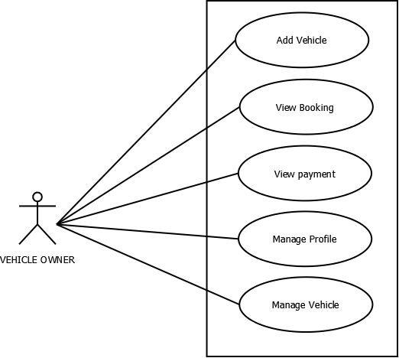

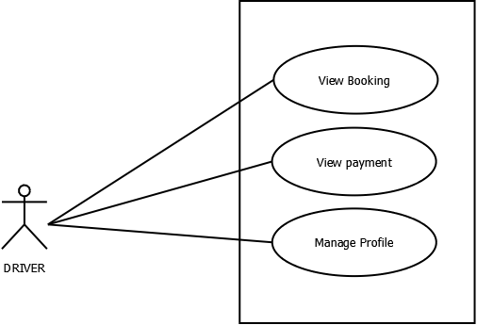

**B. Sequence diagram**

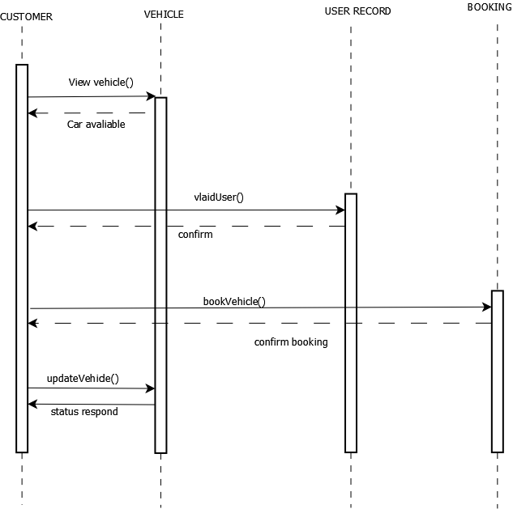

**C. Collaboration diagram**

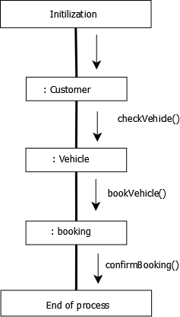

**D. Statechart diagram**

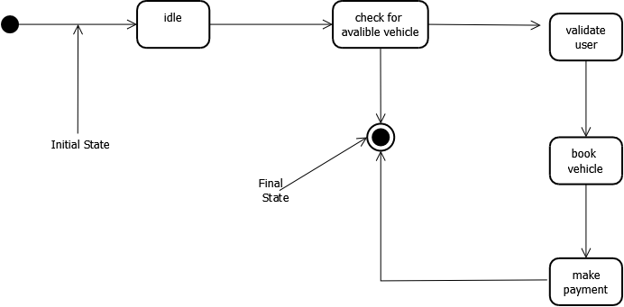

**E. Activity diagram**

